PYTHON lists

[Python Tuples](https://www.w3schools.com/python/python_tuples.asp)

A tuple, in python, is a data structure very similar to lists. Their difference is that unlike lists, the tuple is immutable. This means that once you create a tuple, you can't modify its elements, add new elements, or remove existing elements.

**SYNTAX**

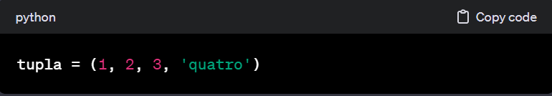 The basic syntax for creating a tuple is to use parentheses () and separate elements with commas.

**ACCESS TO ELEMENTS**

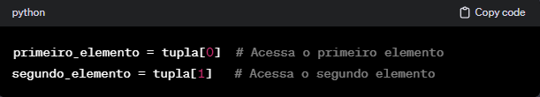The elements of a tuple can be accessed using indexing, just like in lists.

**IMMUTABILITY**

The immutability of one of the tuples means that you cannot modify existing elements, add new elements, or remove elements from the tuple after it has been created. This makes them more secure in certain contexts and useful in situations where changing the data is not desired.

**BUILT-IN FUNCTIONS**

* **Len(): returns the number of elements in the tuple;**
* **Count(): returns the number of occurrences of an element in the tuple;**
* 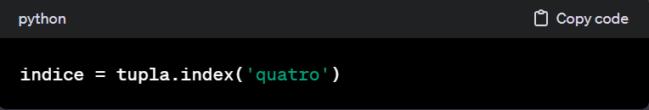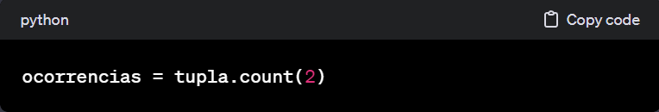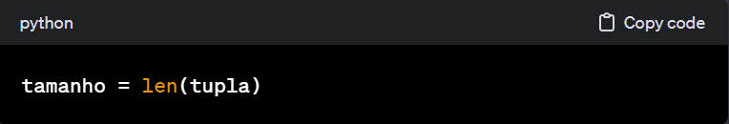**Index(): Returns the index of the first occurrence of an element in the tuple;**

**WHEN TO USE TUPLES?**

* When you have data that should not be changed;
* To represent a collection of ordered and immutable elements
* When you want to ensure data integrity;

Tuples are useful in many scenarios, and their immutability makes them a suitable choice in certain situations.